In my design, in order to achieve a better OOD and satisfy the requirement, I have created a lot of classes for different entity classes.

I created a basic class called Entity which includes String name attributes and makes all inventory(Weapon, Armor, Spell, and Potion) classes and Creature class to extend Entity class, since all these classes have common attributes. Moreover, I placed some common attributes in the creature class and let heroes and monsters inherit him, because heroes and monsters have some similar attributes, while their attributes are not the same as the inventory class.

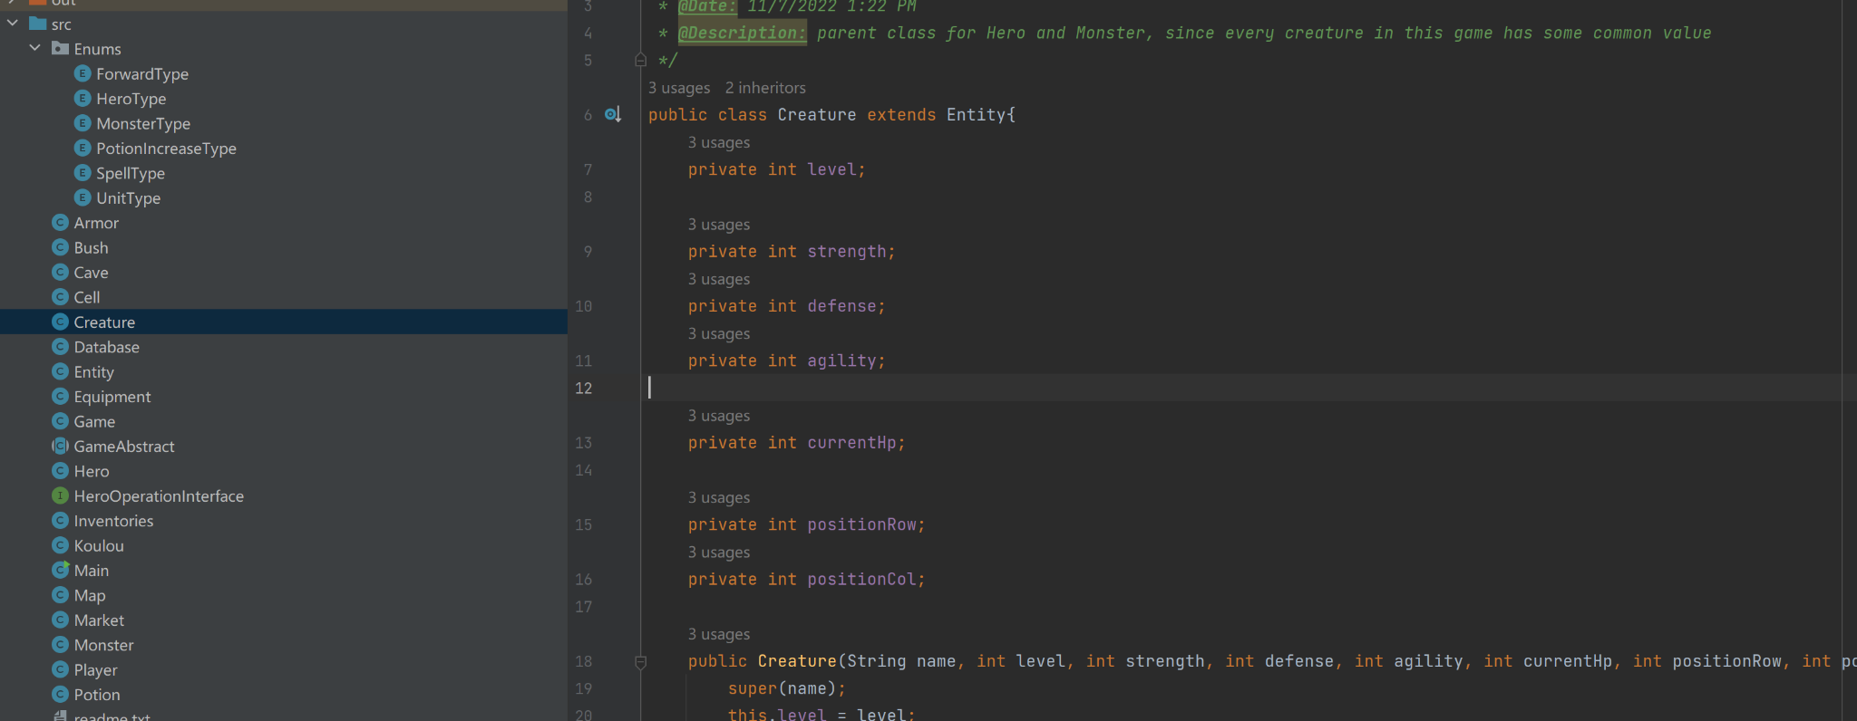

Not only that, but I use a lot of Enum classes in my design because using them allows me to distinguish between different entities within the same entity, like UnityType Enum.

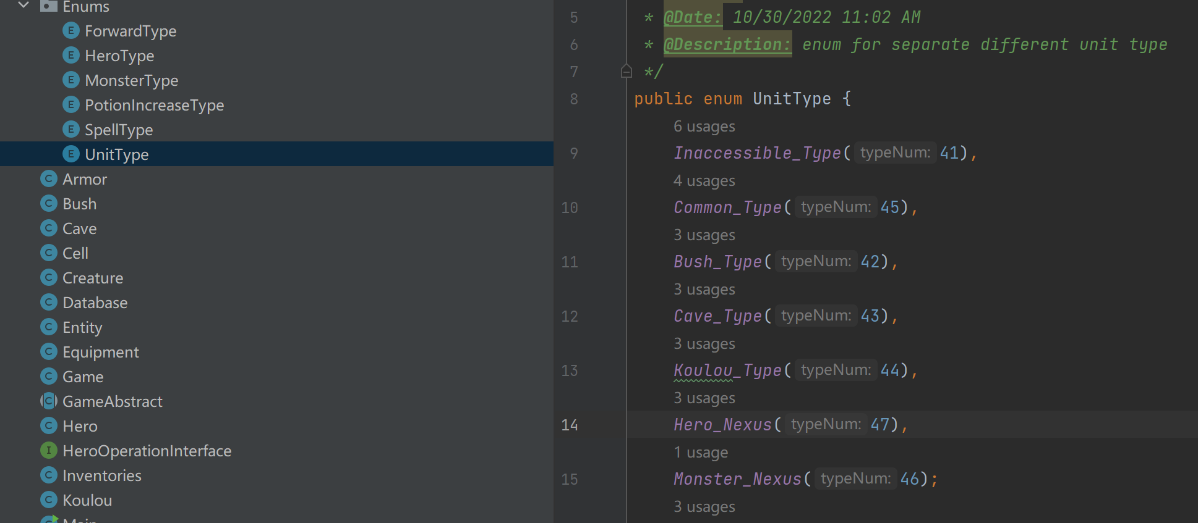

I use it to distinguish between the different types of cells in the map, and the values attached to it help me print different background colors for the map.

Finally, to achieve High Aggregation and Low Coupling in the OOD, In my design, the Game class is only responsible for controlling the mobilization of the control game. For example, for the hero property setting changes or movement and other such hero actions only exist in the hero class. This

also includes the Monster class and others.

A small reminder, Map in the game is colored to indicate various types of grids, copied map in the example input/output section is not able to fully support that display. Please check the map by running the program, and I can not add images to the readme.txt.

